Assignment 14 – Challenging Cases

# Case 1

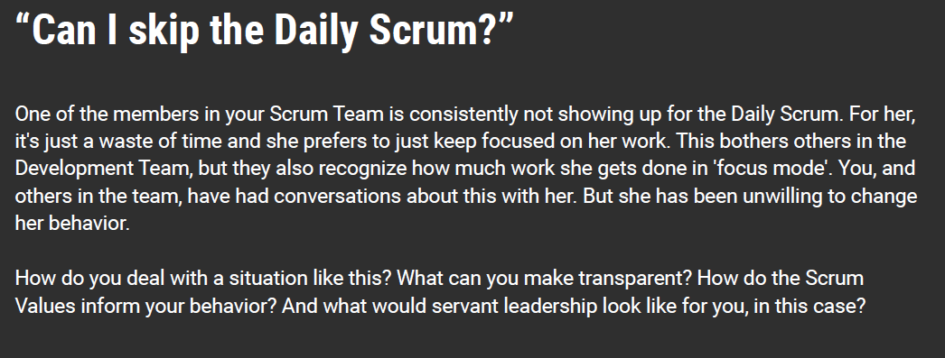

## Solution:

If any team member consistently fails to show up for the daily Scrum, I would reach out to them to understand their reservations about joining the meeting. I would encourage her to join the discussion. I would recommend that it is necessary to join these meetings for a healthy and functioning team. If there’s something that she needs to be adjusted about the scrum meetings, the team can discuss and adapt to accommodate everyone’s suggestions.

A smooth operation and a healthy Scrum require transparency, openness, and honesty. They should voice their opinions and suggestions to make a better team that works well together.

A successful Scrum team has these five values: Courage, Focus, Commitment, Respect, and Openness (Scrum.org). She falls short on three of these five values of Scrum. Courage to do the right thing and join the daily meetings. With respect to other team members and the Scrum process. She is open to discussing the work in a relaxed environment and taking feedback from her team members.

A servant leader encourages people to act through persuasion rather than authority (Gay, 2021). The Scrum Master empowers the team to self-organize, self-manage and self-deliver. The Scrum Master’s role is not to intervene in the team’s dynamic but to look at the overall process.

# Case 2

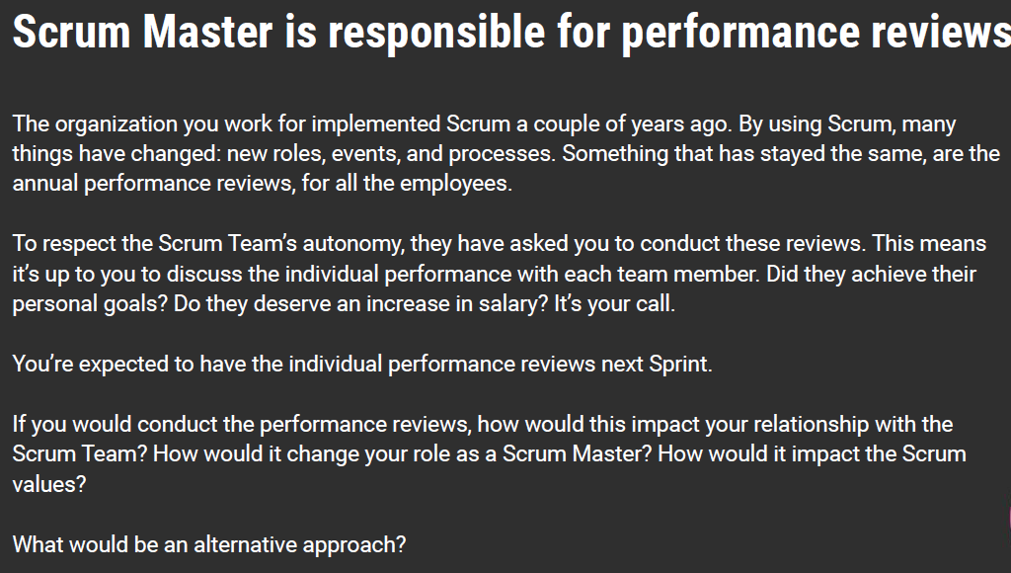

## Solution:

Scrum teams are supposed to be self-organize, self-manage, and self-deliver. In the retrospective, the team discusses: what went well during the sprint cycle? What went wrong during the sprint cycle? And what could we do differently to improve? (Tech at GSA, n.d.)

If the Scrum Master involves themselves in this process, the next sprint would be catered towards serving the servant leader rather than working on the team to improve for the next iteration. Disturbing this scrum process will have a lasting impact on the team and team’s dynamic with the Scrum Master. It violates all five scrum values.

It would be better if the product owner handled this review process as an alternative. Or let the team go through their retrospective, and based on this outcome, the management team or the senior staff can come to a consensus on the promotion and pay hike.

# Case 3

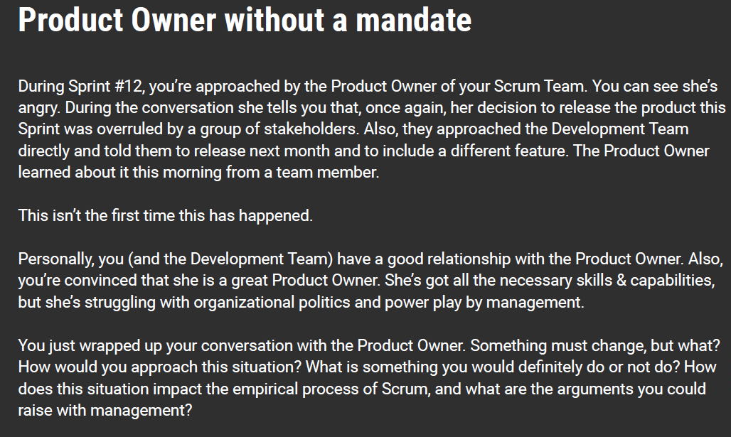

## Solution:

Regardless of the mature relationship with the product owner or the stakeholders. The agile process has a simple set of rules. The rules say that the backlog items and priorities are decided by the product owner, stakeholders, team, and the scrum master at the sprint planning phase of the project. User stories in the priority queue can be revisited at the end of each iteration for reprioritization or adding/removing new items on the queue.

The team can advise the stakeholders to reach out to them in an official capacity. If the stakeholders persist in meeting the teams for adding items on the backlog, the teams can involve the scrum master and the product owner. If the stakeholders continue to have a meeting with the team members, the team can log the work items the stakeholders want to work on but not prioritize them.

The Scrum process is based on reacting to changes in the requirements. But there are some rules to it. The Scrum process accommodates the difference at the end of each iteration cycle. Suppose the stakeholders are asking for changes in the existing backlog items. The management team can discuss with the stakeholders about delivering the right product for the stakeholders in a way that can best the competition. Deliver the agreed-upon product at the agreed-upon time.

# Bibliography

Gay, B. (2021, March 1). *The New Leadership Dynamics*. Retrieved from Project Management Institute: https://www.pmi.org/learning/library/post-pandemic-organizations-reshaped-expectations-opportunities-12924

Scrum.org. (n.d.). *Values Of Scrum.* Retrieved from Scrum.org: https://scrumorg-website-prod.s3.amazonaws.com/drupal/2018-05/ScrumValues-Tabloid.pdf

Tech at GSA. (n.d.). *GSA Tech Guides*. Retrieved from Tech at GSA: https://tech.gsa.gov/guides/conducting_sprint_retrospective/